Final - Homework 220

Phan Anh Le

2024-05-03

library(dplyr)  
library(ggplot2)  
library(rms)  
library(ResourceSelection)  
Data <- read.csv("C:/Users/admin/Downloads/heart.csv")  
View(Data)

### Introduction

In my final project, I will apply logistic regression to a dataset that provided the data of heart attack. This dataset contains variables as age, sex, chest pain type, resting blood pressure rate, cholestoral rate, fasting blood sugar, maximum heart rate achieved, vv. By applying the logistic regression, I aim to predict if the heart attack happens base on the cholestoral rate and the maximum heart rate achieved.

### Validate variables

summary(Data)

## age sex cp trtbps   
## Min. :29.00 Min. :0.0000 Min. :0.000 Min. : 94.0   
## 1st Qu.:47.50 1st Qu.:0.0000 1st Qu.:0.000 1st Qu.:120.0   
## Median :55.00 Median :1.0000 Median :1.000 Median :130.0   
## Mean :54.37 Mean :0.6832 Mean :0.967 Mean :131.6   
## 3rd Qu.:61.00 3rd Qu.:1.0000 3rd Qu.:2.000 3rd Qu.:140.0   
## Max. :77.00 Max. :1.0000 Max. :3.000 Max. :200.0   
## chol fbs restecg thalachh   
## Min. :126.0 Min. :0.0000 Min. :0.0000 Min. : 71.0   
## 1st Qu.:211.0 1st Qu.:0.0000 1st Qu.:0.0000 1st Qu.:133.5   
## Median :240.0 Median :0.0000 Median :1.0000 Median :153.0   
## Mean :246.3 Mean :0.1485 Mean :0.5281 Mean :149.6   
## 3rd Qu.:274.5 3rd Qu.:0.0000 3rd Qu.:1.0000 3rd Qu.:166.0   
## Max. :564.0 Max. :1.0000 Max. :2.0000 Max. :202.0   
## exng oldpeak slp caa   
## Min. :0.0000 Min. :0.00 Min. :0.000 Min. :0.0000   
## 1st Qu.:0.0000 1st Qu.:0.00 1st Qu.:1.000 1st Qu.:0.0000   
## Median :0.0000 Median :0.80 Median :1.000 Median :0.0000   
## Mean :0.3267 Mean :1.04 Mean :1.399 Mean :0.7294   
## 3rd Qu.:1.0000 3rd Qu.:1.60 3rd Qu.:2.000 3rd Qu.:1.0000   
## Max. :1.0000 Max. :6.20 Max. :2.000 Max. :4.0000   
## thall output   
## Min. :0.000 Min. :0.0000   
## 1st Qu.:2.000 1st Qu.:0.0000   
## Median :2.000 Median :1.0000   
## Mean :2.314 Mean :0.5446   
## 3rd Qu.:3.000 3rd Qu.:1.0000   
## Max. :3.000 Max. :1.0000

### Clean data

Data_new <- subset(Data, select = c(age, chol, thalachh, output))  
Data_new <- na.omit(Data_new)  
summary(Data_new)

## age chol thalachh output   
## Min. :29.00 Min. :126.0 Min. : 71.0 Min. :0.0000   
## 1st Qu.:47.50 1st Qu.:211.0 1st Qu.:133.5 1st Qu.:0.0000   
## Median :55.00 Median :240.0 Median :153.0 Median :1.0000   
## Mean :54.37 Mean :246.3 Mean :149.6 Mean :0.5446   
## 3rd Qu.:61.00 3rd Qu.:274.5 3rd Qu.:166.0 3rd Qu.:1.0000   
## Max. :77.00 Max. :564.0 Max. :202.0 Max. :1.0000

### Check for correlation

Data_new %>% ggplot(aes(chol, output))+  
 geom_point(color = "blue")+  
 geom_smooth(method = "lm",color = "orange")+  
 stat_smooth(method = "glm",method.args = list(family= "binomial"))

## `geom_smooth()` using formula = 'y ~ x'  
## `geom_smooth()` using formula = 'y ~ x'

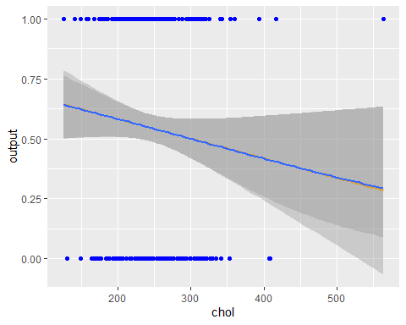

Data_new %>% ggplot(aes(thalachh, output))+  
 geom_point(color = "red")+  
 geom_smooth(method = "lm",color = "darkblue")+  
 stat_smooth(method = "glm",method.args = list(family= "binomial"))

## `geom_smooth()` using formula = 'y ~ x'  
## `geom_smooth()` using formula = 'y ~ x'

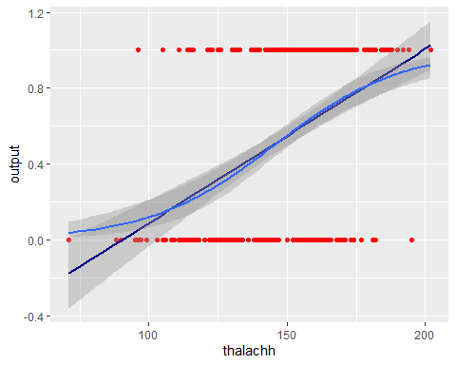 The first graph shows a negative correlation between chol and output. It means that if the cholestoral increase, there will be a lower chance of heart attack.

The second graph indicates a positive relationship between thalachh and output. It can be observable that the maximum heart rate achieved, the higher chance of heart attack happened.

### Generated Linear Model

# Model 1  
glm1 <- glm(output~ chol + thalachh, Data_new, family = binomial)  
summary(glm1)

##   
## Call:  
## glm(formula = output ~ chol + thalachh, family = binomial, data = Data_new)  
##   
## Deviance Residuals:   
## Min 1Q Median 3Q Max   
## -2.0894 -1.0199 0.5823 0.9523 2.0313   
##   
## Coefficients:  
## Estimate Std. Error z value Pr(>|z|)   
## (Intercept) -5.506770 1.127885 -4.882 1.05e-06 ***  
## chol -0.003805 0.002425 -1.569 0.117   
## thalachh 0.044342 0.006588 6.731 1.69e-11 ***  
## ---  
## Signif. codes: 0 '***' 0.001 '**' 0.01 '*' 0.05 '.' 0.1 ' ' 1  
##   
## (Dispersion parameter for binomial family taken to be 1)  
##   
## Null deviance: 417.64 on 302 degrees of freedom  
## Residual deviance: 356.76 on 300 degrees of freedom  
## AIC: 362.76  
##   
## Number of Fisher Scoring iterations: 3

# Coefficients

Intercept (-5.506770): The intercept in this model represents the log-odds of the outcome being positive when both cholesterol and maximum heart rate are zero. The value is highly significant (p-value = 1.05e-06), suggesting a strong baseline effect against the positive outcome under theoretical conditions where chol and thalach are at their minimum.

Cholesterol (Chol) (-0.003805): The coefficient for cholesterol indicates that an increase in cholesterol levels decreases the log-odds of the positive outcome by -0.003805, although this effect is not statistically significant (p-value = 0.117). This suggests that cholesterol may not have a strong independent impact on the outcome in the presence of heart rate as another predictor.

Maximum Heart Rate (Thalach) (0.044342): Each unit increase in maximum heart rate significantly increases the log-odds of the positive outcome by 0.044342, with a very high level of statistical significance (p-value = 1.69e-11). This indicates that thalach is a powerful predictor of the outcome, providing clear evidence that higher heart rate is associated with an increased likelihood of the positive outcome.

Residual Deviance (356.76 on 300 degrees of freedom): The substantial reduction in deviance suggests that the model, including both cholesterol and heart rate, explains a significant portion of the variability in the outcome. This improvement in fit compared to the null model, which includes no predictors, is notable.

AIC (362.76): The Akaike Information Criterion score of 362.76 balances the model’s accuracy against its complexity. While this AIC is lower than some previous single-predictor models, indicating a more effective model in terms of explanatory power and simplicity.

# Model 2  
glm2 <- glm(output ~ chol, Data_new, family = binomial)  
summary(glm2)

##   
## Call:  
## glm(formula = output ~ chol, family = binomial, data = Data_new)  
##   
## Deviance Residuals:   
## Min 1Q Median 3Q Max   
## -1.425 -1.241 1.015 1.093 1.567   
##   
## Coefficients:  
## Estimate Std. Error z value Pr(>|z|)   
## (Intercept) 1.001617 0.571467 1.753 0.0797 .  
## chol -0.003338 0.002269 -1.471 0.1412   
## ---  
## Signif. codes: 0 '***' 0.001 '**' 0.01 '*' 0.05 '.' 0.1 ' ' 1  
##   
## (Dispersion parameter for binomial family taken to be 1)  
##   
## Null deviance: 417.64 on 302 degrees of freedom  
## Residual deviance: 415.43 on 301 degrees of freedom  
## AIC: 419.43  
##   
## Number of Fisher Scoring iterations: 4

# Coefficient

Intercept (1.001617): The intercept value indicates the log-odds of the outcome being positive when cholesterol level is at zero. This coefficient is not statistically significant (p-value = 0.097), suggesting that the baseline effect in the model, without considering cholesterol, does not significantly influence the outcome.

Cholesterol (Chol) (-0.003338): Each unit increase in cholesterol level decreases the log-odds of the outcome by -0.003338. Although the effect suggests a negative association between cholesterol levels and the outcome, this coefficient is not statistically significant (p-value = 0.1412), indicating that cholesterol levels might not have a strong impact on the outcome in this model setting.

Residual Deviance (415.43 on 301 degrees of freedom): The model reduces the residual deviance slightly from the null deviance of 417.64 on 302 degrees of freedom, indicating a minimal improvement in model fit upon including cholesterol as a predictor.

AIC (419.43): The Akaike Information Criterion score of 419.43 reflects the model’s balance between accuracy and complexity. The slight decrease compared to the null model suggests a minimal contribution of cholesterol to improving the model’s explanatory power.

# Model 3  
glm3 <- glm(output~thalachh, Data_new, family = binomial)  
summary(glm3)

##   
## Call:  
## glm(formula = output ~ thalachh, family = binomial, data = Data_new)  
##   
## Deviance Residuals:   
## Min 1Q Median 3Q Max   
## -2.1383 -1.0780 0.6043 0.9200 2.1354   
##   
## Coefficients:  
## Estimate Std. Error z value Pr(>|z|)   
## (Intercept) -6.391452 0.987133 -6.475 9.50e-11 ***  
## thalachh 0.043951 0.006531 6.729 1.71e-11 ***  
## ---  
## Signif. codes: 0 '***' 0.001 '**' 0.01 '*' 0.05 '.' 0.1 ' ' 1  
##   
## (Dispersion parameter for binomial family taken to be 1)  
##   
## Null deviance: 417.64 on 302 degrees of freedom  
## Residual deviance: 359.26 on 301 degrees of freedom  
## AIC: 363.26  
##   
## Number of Fisher Scoring iterations: 4

# Coefficient

Intercept (-6.391452): The intercept value indicates the log-odds of the outcome being positive when the maximum heart rate (thalach) is zero. This coefficient is highly significant (p-value = 9.50e-11), suggesting a strong baseline effect in the model. The negative value indicates a low likelihood of the outcome being positive at this baseline level of heart rate, which is theoretically very low (near zero).

Thalach (0.043951): Each unit increase in maximum heart rate significantly increases the log-odds of the outcome by 0.043951. This effect is highly significant (p-value = 1.71e-11), highlighting a strong positive association between heart rate and the likelihood of the outcome. The odds ratio, exp(0.043951), suggests that each unit increase in heart rate significantly increases the probability of the positive outcome.

Residual Deviance (359.26 on 301 degrees of freedom): The decrease in residual deviance from the null deviance of 417.64 on 302 degrees of freedom to 359.26 on 301 degrees of freedom indicates that the model fits the data significantly better than the null model, which only includes the intercept.

AIC (363.26): The Akaike Information Criterion score of 363.26 reflects the model’s balance between accuracy and complexity. This score demonstrates the model’s effectiveness in using maximum heart rate to describe the outcome while considering the complexity of the dataset, which might influence comparisons with other models.

### Do the logistic regression model

lrm(output~ chol + thalachh, Data_new)

## Logistic Regression Model  
##   
## lrm(formula = output ~ chol + thalachh, data = Data_new)  
##   
## Model Likelihood Discrimination Rank Discrim.   
## Ratio Test Indexes Indexes   
## Obs 303 LR chi2 60.88 R2 0.243 C 0.750   
## 0 138 d.f. 2 R2(2,303)0.177 Dxy 0.500   
## 1 165 Pr(> chi2) <0.0001 R2(2,225.4)0.230 gamma 0.500   
## max |deriv| 2e-06 Brier 0.202 tau-a 0.249   
##   
## Coef S.E. Wald Z Pr(>|Z|)  
## Intercept -5.5068 1.1279 -4.88 <0.0001   
## chol -0.0038 0.0024 -1.57 0.1166   
## thalachh 0.0443 0.0066 6.73 <0.0001

# Remove maximum heart rate

lrm(output ~ chol, Data_new)

## Logistic Regression Model  
##   
## lrm(formula = output ~ chol, data = Data_new)  
##   
## Model Likelihood Discrimination Rank Discrim.   
## Ratio Test Indexes Indexes   
## Obs 303 LR chi2 2.21 R2 0.010 C 0.570   
## 0 138 d.f. 1 R2(1,303)0.004 Dxy 0.140   
## 1 165 Pr(> chi2) 0.1373 R2(1,225.4)0.005 gamma 0.141   
## max |deriv| 2e-10 Brier 0.246 tau-a 0.070   
##   
## Coef S.E. Wald Z Pr(>|Z|)  
## Intercept 1.0016 0.5715 1.75 0.0797   
## chol -0.0033 0.0023 -1.47 0.1412

# Remove cholestoral

lrm(output ~ thalachh, Data_new)

## Logistic Regression Model  
##   
## lrm(formula = output ~ thalachh, data = Data_new)  
##   
## Model Likelihood Discrimination Rank Discrim.   
## Ratio Test Indexes Indexes   
## Obs 303 LR chi2 58.38 R2 0.234 C 0.748   
## 0 138 d.f. 1 R2(1,303)0.173 Dxy 0.497   
## 1 165 Pr(> chi2) <0.0001 R2(1,225.4)0.225 gamma 0.502   
## max |deriv| 5e-08 Brier 0.203 tau-a 0.247   
##   
## Coef S.E. Wald Z Pr(>|Z|)  
## Intercept -6.3915 0.9871 -6.47 <0.0001   
## thalachh 0.0440 0.0065 6.73 <0.0001

We can observe the performance differences among the three models analyzed. Each model showcases unique strengths, with their C and Dxy values indicating various levels of predictive accuracy.

Firstly, Model 1, which includes predictors cholesterol and thalach, exhibits the best overall fit among them. Its C-stat of 0.75 and Dxy of 0.50 demonstrate solid discriminative power, establishing it as the most effective model in differentiating between the positive and negative outcomes of the dataset.

Secondly, Model 2, relying solely on cholesterol as a predictor, shows considerably weaker performance. The C-stat of 0.570 and a Dxy of 0.140 suggest limited ability to discriminate effectively between outcomes, highlighting the insufficiency of using cholesterol alone as a reliable predictor.

Lastly, Model 3, which uses thalach as the sole predictor, performs commendably for a model based on a single variable. Its C-stat of 0.748 and Dxy of 0.497 are indicative of good predictive accuracy and discriminative ability, making it a robust choice for simpler predictive needs.

Thus, Model 1 demonstrates remarkable discriminative power, establishing it as the most effective model.

### Residue’s Distribution

Data_new1 <- Data_new %>% mutate(res=resid(glm1),fit = fitted(glm1))  
Data_new1 %>%  
 ggplot(aes(res))+  
 geom_histogram(fill = "green", color = "grey")

## `stat_bin()` using `bins = 30`. Pick better value with `binwidth`.

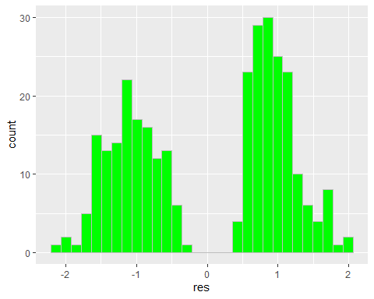

Data_new1 %>%  
 ggplot(aes(fit, res))+  
 geom_point(color = "orange")

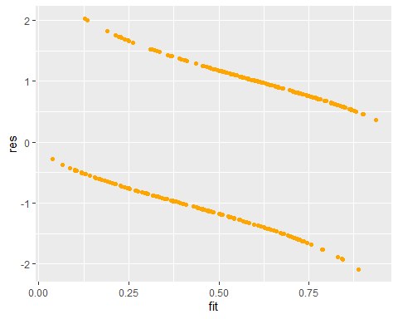

The histogram indicates that the distribution is not normal, which is expected for residuals from a logistic regression model given the binary nature of the outcome. Moreover, according to the plot, as we can see, more than 95% of the residuals are between -2 and 2. This suggests that the model provides a good fit for certain sections of the data. The residuals versus fitted values plot shows a clear funnel shape, with residuals spreading out as the fitted values approach 0.25 and 0.75. This pattern is typical in logistic regression models due to the nature of the binomial distribution and indicates heteroscedasticity.

### Do the Hosmer–Lemeshow test

hoslem.test(Data_new1$output, Data_new1$fit, g = 10)

##   
## Hosmer and Lemeshow goodness of fit (GOF) test  
##   
## data: Data_new1$output, Data_new1$fit  
## X-squared = 9.2343, df = 8, p-value = 0.3229

Chi-Squared (X-squared): The test statistic is reported at 9.2343. This value represents the sum of squared deviations between the observed and expected outcomes across deciles of predicted probabilities, based on the model’s estimations.

Degrees of Freedom (df): The test utilizes 8 degrees of freedom. This count generally arises from dividing the dataset into ten groups (deciles), with the degrees of freedom calculated as the number of groups minus two.

P-value: The recorded p-value is 0.3229, which is significantly above the commonly accepted significance threshold of 0.05.

The high p-value (0.3229) from the Hosmer and Lemeshow test indicates a good fit for the model, as it suggests there is no significant deviation between observed and predicted outcomes across the various deciles of predicted probabilities. This result implies that the model is effectively capturing the actual trends within the data.

### Make Prediction

make_predict <- data.frame(  
 chol = c(170,283),   
 thalachh = c(180,85)  
)

pre <- predict(glm1, newdata = make_predict, interval = "prediction", level = 0.95)  
print(pre)

## 1 2   
## 1.828049 -2.814387

The two predictions yield one positive, which means “closed” and one negative, which is “not closed”, result. This outcome aligns with expectations, as the first prediction involves a lower cholestoral rate and a higher maximum heart rate achieved, while the second involves a higher cholestoral rate and lower maximum heart rate achieved.

### Conclusion

This project applied logistic regression to predict heart attack occurrences based on cholesterol levels and maximum heart rate and the result shows some good sights. The most comprehensive model, combining both predictors, demonstrated the strongest fit and predictive power, as evidenced by significant p-values and a robust Hosmer and Lemeshow test result, indicating a good model fit.

The analysis confirmed the model’s effectiveness in practical scenarios, such as predicting heart attack risk, which can aid in clinical decision-making and preventative healthcare strategies. Overall, this project highlights the value of logistic regression in health sciences, offering a solid foundation for further research and application in medical settings to enhance patient care and preventative measures.